1.To assess the impact of boundary conditions, initial conditions and physical and numerical parameters by modeling the natural (Eigen) and forced behaviour of a harbour (Fig. 1‐1).

Impact of boundary condition

In boundary condition, we only consider the change of parameters of the sea eg. Amplitude and phase.

2.Assess the influence of bottom friction (roughness and depth)

Roughness formula: Chezy equation

Uniform U=500 ; V=500

Based on these parameters, it is high friction comparing to the default 65. After running model with the same other parameters generated before, generally we get,

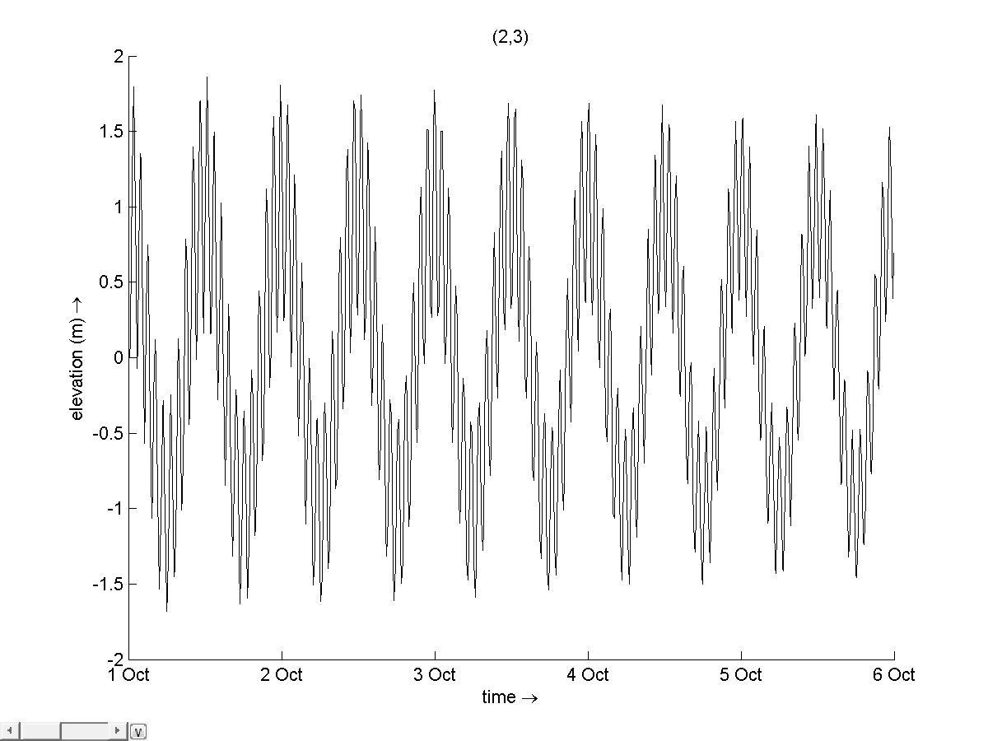

See a lot of oscillations with time